Scenario | User Account | Screenshot
on plan | BP1100002282@DTEACCEPT.COM  Current RC: EFR_D1_8  BP: 1100002282  CA: 910000012963  Installation: 7000010442 | 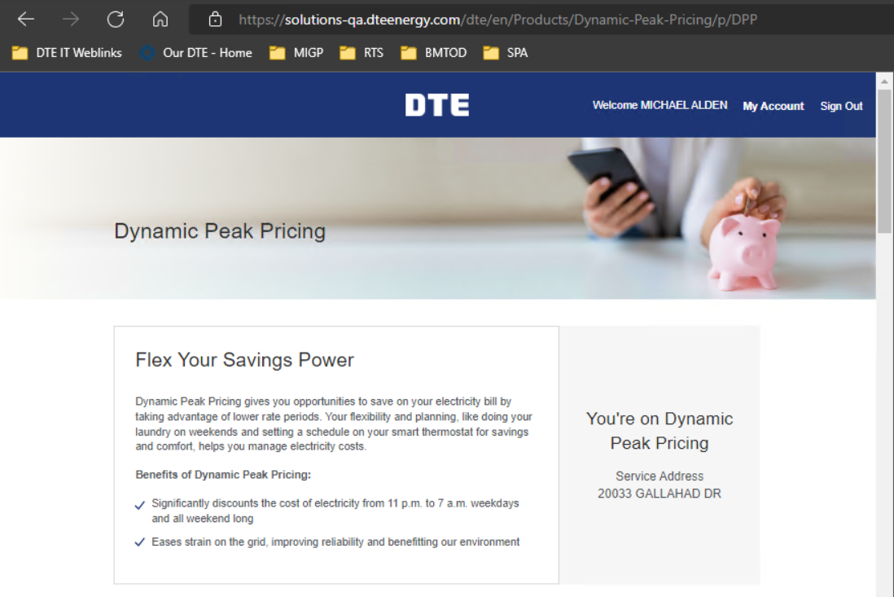
not on plan | BP1100002763@DTEACCEPT.COM
Single Account, No Enrolment | BP1100002691@DTEACCEPT.COM | 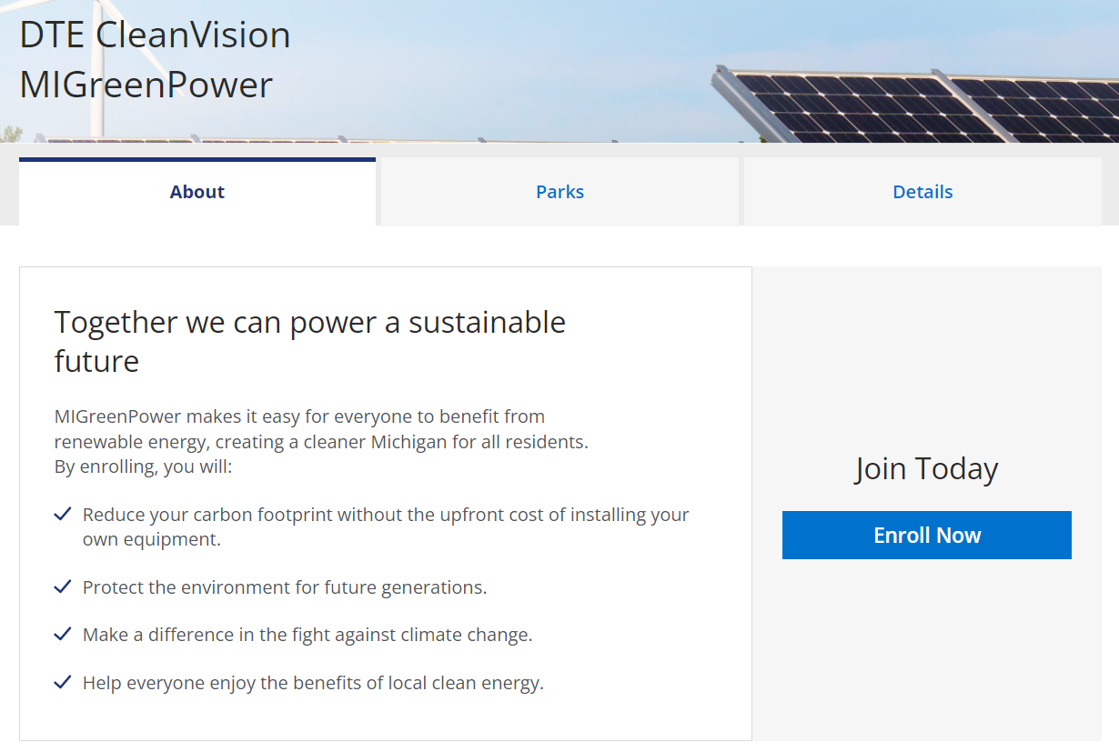
Single Account, Enrolled, Change Eligible | BP1100002759@DTEACCEPT.COM | 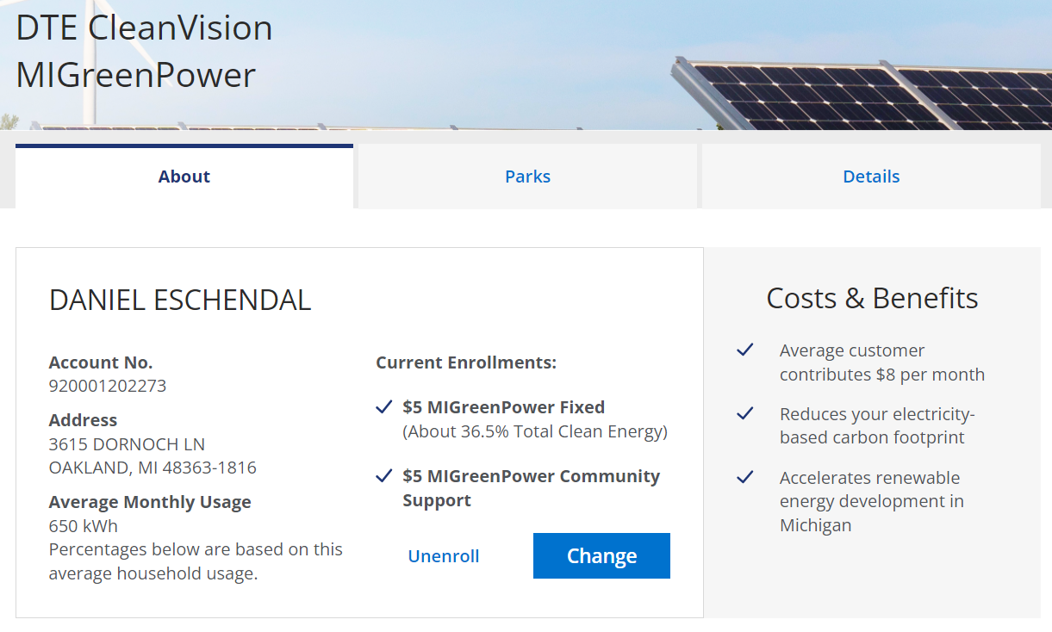
Single Account, Enrolled, Change Ineligible | BP1100002763@DTEACCEPT.COM | 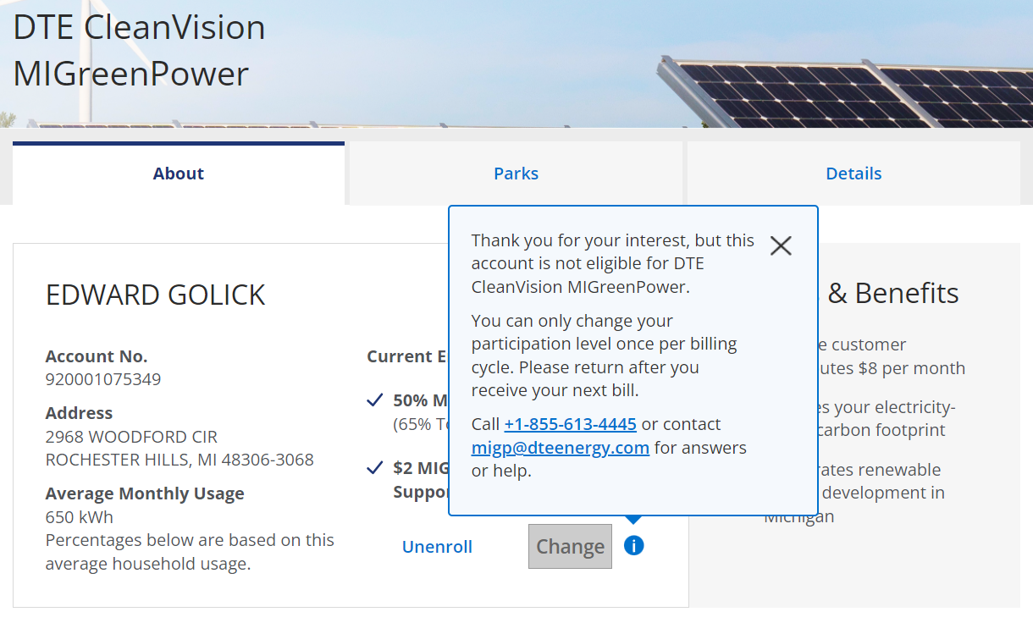
Single Account, Enrolled, Unmetered | BP1100222299@DTEACCEPT.COM | 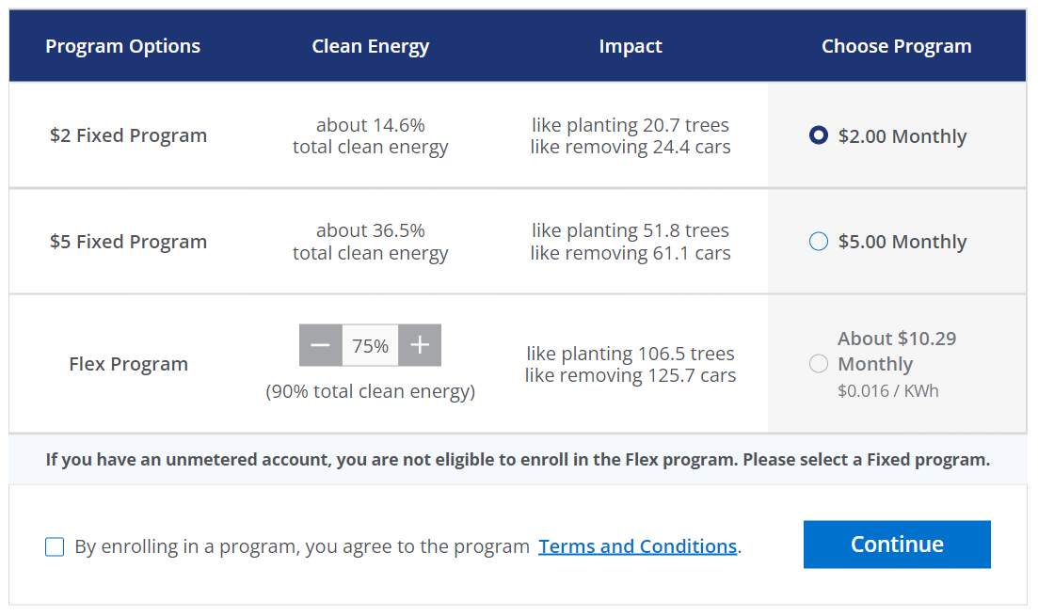
Single Account, Enrolled, Custom Program | BP1100002773@DTEACCEPT.COM | 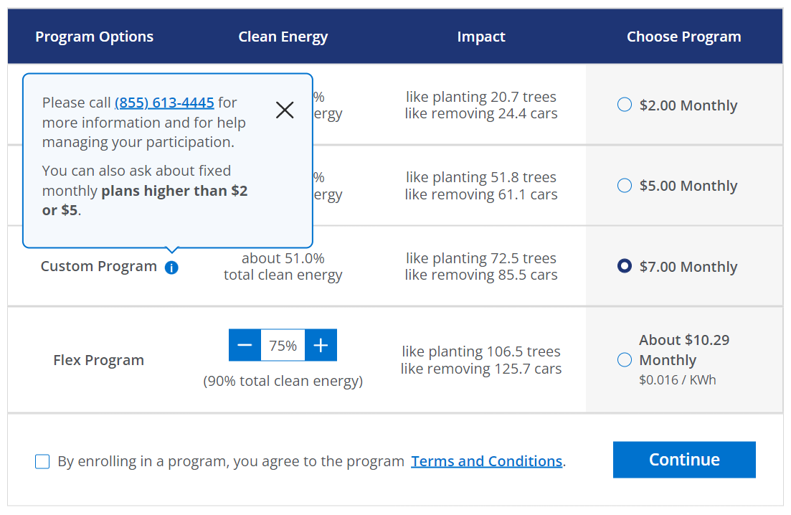
Multiple Accounts, Not Enrolled | BP1100002746@DTEACCEPT.COM | 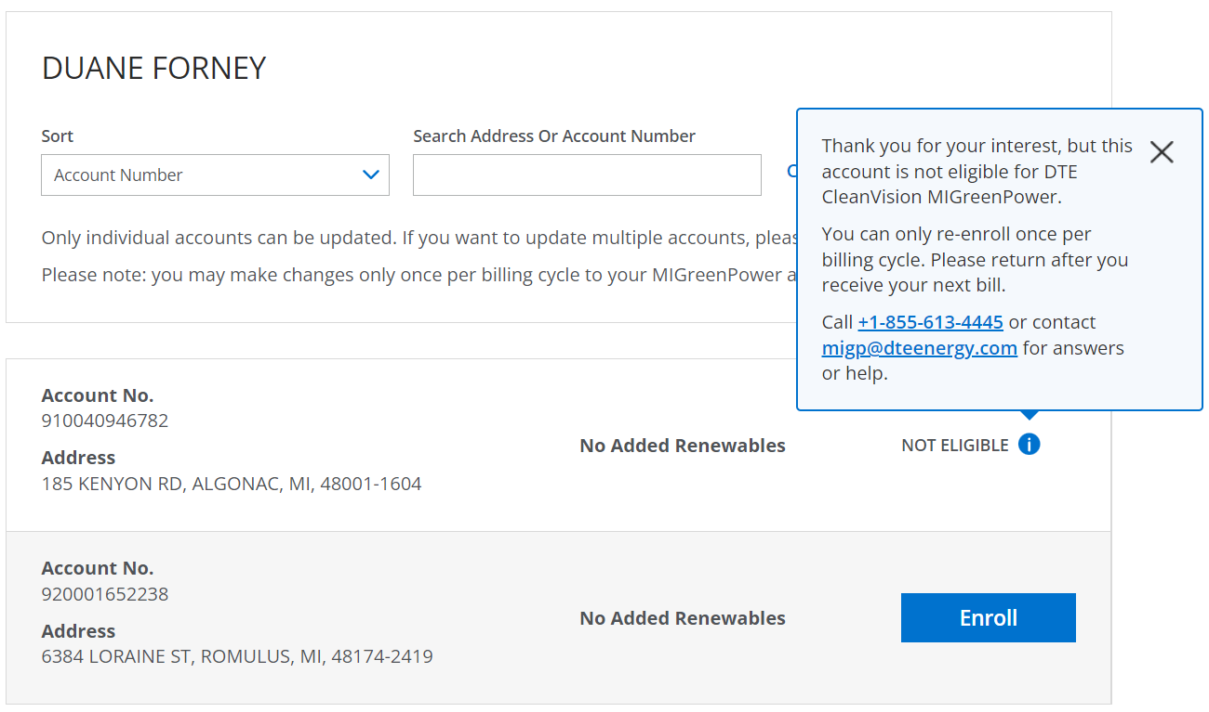
Multiple Accounts (>5 accounts), Mixed Enrolments | BP1100002492@DTEACCEPT.COM | 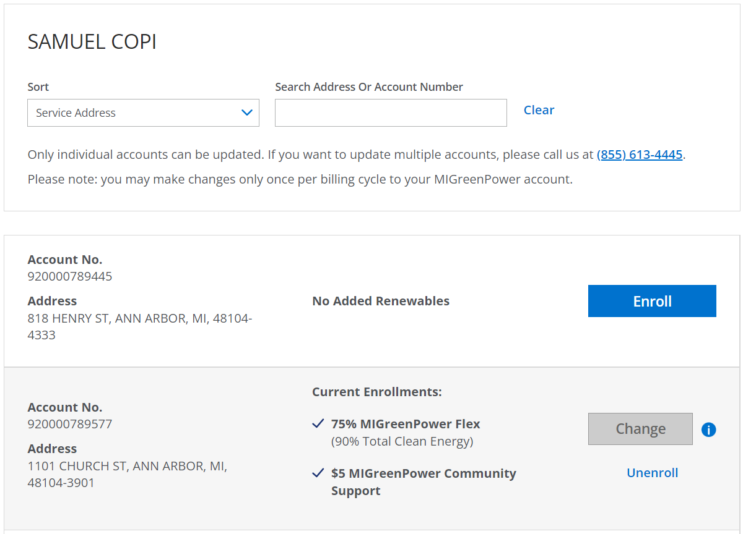
Guest Account | CARDINAL HVC LLC  920004585930  111395410

